**Estimated Local Hospital Bed Utilization**

This small brief will explain, and show the calculations and rational behind the discussed metric in the AFIT CHAD dashboard.

**Data**

|  |  |  |
| --- | --- | --- |
| **Data** | **Source** | **Explanation** |
| Hospital List | American Hospital Directory (AHD), Advana | These sources contain the list for all hospitals in the US along with their locations, number of staffed beds, average historic utilization, total yearly patient discharges, total yearly patient days |
| COVID Case Count | USAFacts | Very widely used site that scrapes all the state health department’s websites to compile COVID cases and deaths each by county |
| County Age Demographics | Census Bureau | Age demographics for every county for up to 2018 estimation |
| Hospitalization Rates | NYC Department of Health and Mental Hygiene | Hospitalization rates for age groups in NYC |

* Data taken from state health departments are the best available representation of case counts
* Hospital’s average utilization could go down during this pandemic as nonessential medical care is not being treated (hospital networks establish what is non-essential to a degree). This possible decrease is not being represented in the calculation since an overestimation of hospital utilization is safer than an underestimation.
* Hospitals do not record their daily bed use and report it every day. It is reported as an average every quarter to Medicare based on discharged patients and patient days.
* Hospital bed counts are limited to General Acute Care and Critical Access type hospitals. These are the hospitals that will treat COVID patients and have the equipment. General Acute Care is your “standard” type of hospital and makes up >65% of all hospitals in the US.
* Average hospital stay for COVID estimated to be 5 days (similar to simple pneumonia), and 7 days in the ICU (extensive pneumonia). Sourced from CDC and Medicare.
* Hospitalization rates taken from NYC Department of Health and Mental Hygiene. NYC has the most cases in America and most countries. The large sample size allows a better picture of hospitalization rates among age groups. NYC is also the most diverse city in this country, therefore representing the best picture of hospitalization rates against “confirmed cases”.

**Methodology**

The first thing to establish is estimated hospitalization rates by county. Below is a table of the NYC age group brackets for hospitalization rates and the Census Bureau’s age groups for population. These were grouped as follows, with the colors corresponding to matching age group buckets:

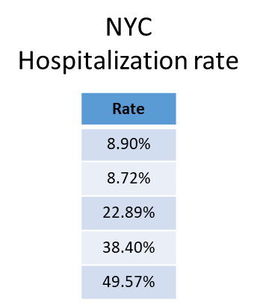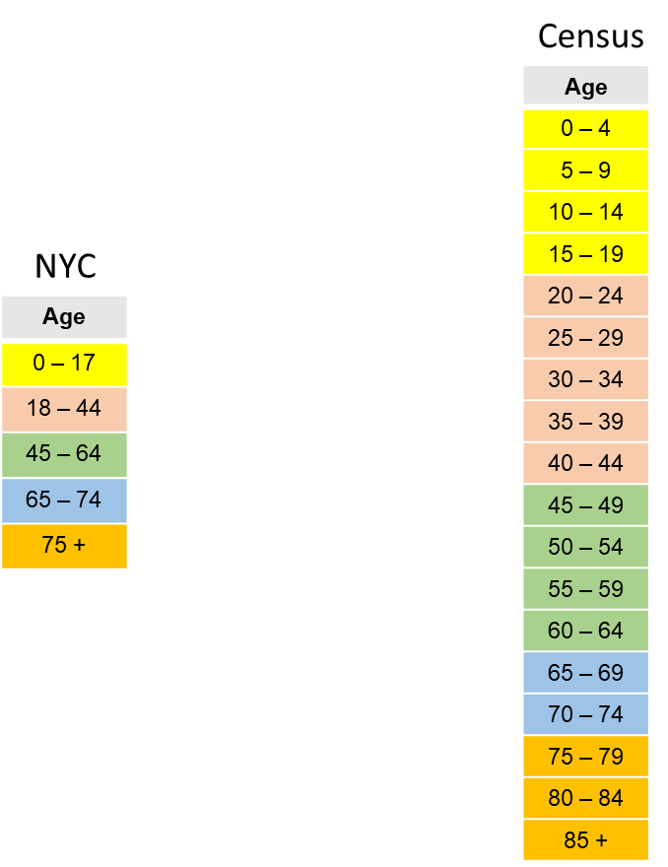

With the census information grouped into 5 age buckets, each county’s age group percent ($AG_{ij}$) was multiplied against their respective hospitalization rates ($HR_{i}$) and summed up to develop an overall weighted average hospitalization rate in each county (${CR}_{j}$) where $i$ is each age group and $j$ is each county.

$${CR}_{j}=\sum_{i}{(AG_{ij})(HR_{i})}$$

The next thing needed is the confirmed cases for each county ($CC_{jt}$), where $j$ is the county and $t$ is the day. This is taken from USAFacts and filtered for each county in the selected radius.

To estimate daily hospital utilization (different from new daily hospitalizations), we use the cumulative current cases for each county, and subtract the cumulative cases from 7 days ago. This is to account for patients that have entered the hospital in the last 7 days and may be still there, since they will still be occupying a bed. 7 days was used over 5 for the safety of overestimating and accounting for lack of data. Therefore, the current hospital utilization ($U$) is calculated as follows:

$$U=\frac{(CC_{jt}-CC_{j(t-7)})*\left(CR_{j}\right)}{HB}+U_{0}$$

Where $U_{0}$ is the average utilization of the hospital beds in that area, and $HB$ is the total staffed hospital beds in the area.